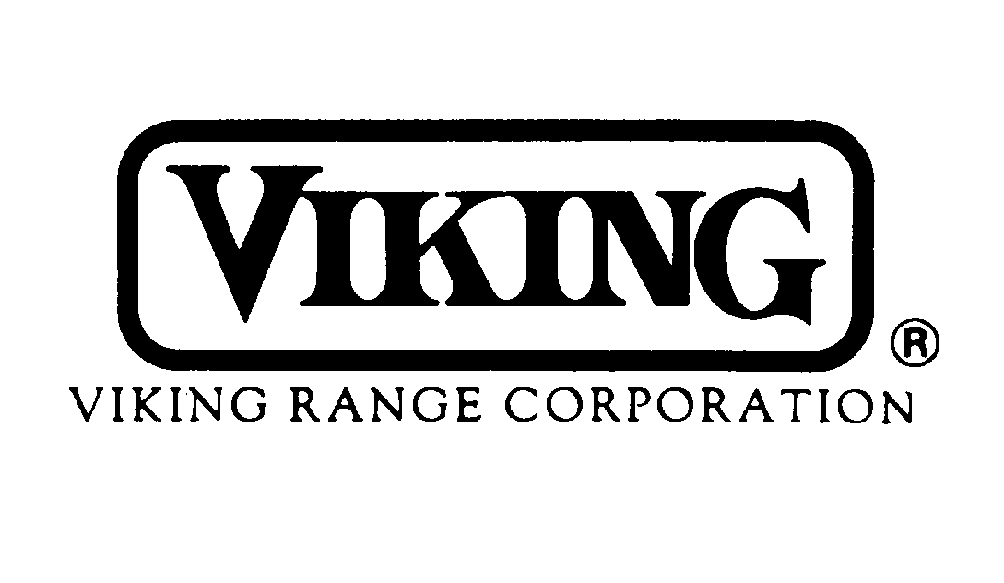

DISTRIBUTOR CO-OP

MARKETING AND ADVERTISING PLAN

Effective January 1, 2006

A well-planned and organized sales and marketing effort by the Viking distributor will result in increased Viking sales which will have a definite, positive impact on the distributor’s bottom line in the form of increased profits. Viking expects to participate in this effort by assisting the Viking distributor with marketing the Viking product line. The Viking Distributor Co-op Marketing and Advertising Plan is intended to provide this assistance.
Among others, some of the most effective ingredients for maintaining a successful Viking distributorship include a professional advertising program; aggressive new dealer efforts; attractive, well-maintained displays; and strong product training. This Plan will assist Viking distributors by providing funds for implementing such efforts at the local level. The Plan consists of the following three components:
- Co-op Marketing and Advertising Program
- Viking Dealer Display Program
- Viking Model Home Program
Payment for all claims submitted is limited to the amount accumulated in the fund.
Every Viking distributor will actively participate in this Plan, and will benefit by more effectively marketing and selling Viking products in their local sales territories.

1. VIKING COOPERATIVE MARKETING AND ADVERTISING PROGRAM
An effective marketing and advertising program is one of the most vital tools of your successful Viking sales effort. National and local advertising introduces the product to a large number of prospects who would be impossible to reach through direct sales. Promotions for the distributor sales force or the retail dealer serve to increase product awareness and provide additional incentives for selling and promoting the Viking product line. Local advertising and promotions are vital tools for your Viking salespeople. The intent of the Viking Cooperative Marketing and Advertising Program is to provide funds for establishing effective advertising and promotions at the local level to enhance your Viking sales.
Viking shares the cost of local advertising and promotions on a generous basis as
outlined below. The importance of a well-planned local advertising and promotion program cannot be overemphasized. Combining Viking and distributor funds with dealer funds on a co-op basis results in more extensive and effective advertising exposure.

FUNDING
An amount equal to 4% of purchases of Viking products will be reserved for the distributor’s use for co-op advertising and promotion. This will apply to those products listed in the Viking Distributor Cost Schedule. Parts and other products not listed in the Distributor Cost Schedule do not qualify. This co-op money is not charged on invoices and therefore is retained by Viking unless used by the distributor under this co-op program. Viking will pay fifty percent (50%) of the cost of approved local advertising and approved promotions completed by the distributor, as described below.

TIME LIMIT FOR USE OF CO-OP FUNDS
Individual distributor co-op reserves are accumulated within the 12 months beginning January 1 and ending December 31. All co-op funds earned during the year must be spent prior to December 31 of that year, and claims must be submitted to Viking by February 15 of the following year.

LIMIT PER EVENT OR PROGRAM
No more than twenty-five percent (25%) of the distributor’s annual co-op fund can be applied to any one project, promotion, or event without prior written approval from the Viking Regional Sales Manager and Vice President-Sales.

CO-OP ADVERTISING AND PROMOTION PAYMENT REQUEST FORM AND PROCEDURES
All claims must be submitted on the Viking Co-op Marketing and Advertising Claim Form. Claims on other forms will be returned. At the end of each quarter, all claims should be listed on this form, signed by an authorized distributor representative, and submitted within 45 days of the end of the quarter to the appropriate Viking Regional Sales Manager. The Viking RSM should review the claim and supporting documentation with the distributor before approving and forwarding to Viking. No backup should be included with this form but should be readily available for audit by the Viking Sales and Finance departments. All backup should be kept available for at least three years for an audit. There should be a specific individual at each distributorship who is responsible for processing co-op claims and can be easily contacted by Viking if questions arise.

CO-OP ADVERTISING GUIDELINES
Approved advertising includes the following:
• Advertising space in local newspapers and newspaper supplements
• Advertising space in magazines and trade journals
• Radio spots and television spots
• Dealer and/or consumer mailings
• Sales support materials and displays
(including shipping charges)
All radio and television scripts must be submitted for prior approval by the Viking Regional Sales Manager.
Special attention should be paid to ensure that the Viking trademark and Viking trade names are protected and that the proper symbols (® or ™) are utilized in all cases. Claims in which the Viking trademark and/or trade name(s) are misused will not be honored.
Misleading ad copy, misrepresentation, illegal competitive practices, libelous reference to competitors, and/or failure to conform to all Federal Trade Commission standards and rulings will disqualify an advertisement from Viking participation. Errors and/or mistakes such as improper grammar, misspelling, photo reversals, etc. may also disqualify an ad from participation if, in the judgment of Viking, the advertisement does not portray Viking in the proper manner and/or image.

GROUP PRODUCT ADS
In advertisements, which include products or services other than Viking, co-op payment will be computed on the basis of the percent of space used for Viking products. The space occupied by Viking products must be computed by the distributor for payment to be made.

ADVERTISING ASSISTANCE
Ad slicks are available from Viking for the distributor’s use in preparing professional Viking ads at the local or regional level. Viking, through its marketing department and advertising agency, will also provide assistance in preparing special or custom Viking ads for use by the distributor. Any charges incurred by Viking in producing such special or custom ads will be billed to the distributor. Fifty percent (50%) of these production costs for such ads may be claimed by the Viking distributor against their co-op fund.

PAYMENT FOR COOPERATIVE ADVERTISING
The distributor should place all advertising with the local media. Copies of actual media invoices must be available at the distributorship; advertising agency invoices may not be substituted for media invoices. If local advertising has been run on television or radio, an affidavit of performance from the station for co-op advertising reimbursement purposes is required, indicating that the advertisement has been scheduled and run. This should be available to Viking along with a copy of the paid invoice, if requested. The Viking distributor can then include this claim with fifty percent (50%) of the amount of the invoice on the next quarterly statement for credit.
Do not deduct co-op advertising or promotion claims from any Viking remittances or invoices. Viking attempts to issue credit promptly for all co-op claims, normally within 30 days of receipt. If credit is not received after 60 days, please contact the Viking Sales Department in writing for follow-up or assistance. Because of the difficulty in researching very old claims, any claims which have not been followed up in writing within 90 days of the date originally filed will not be honored.

SALES PROGRAMS AND PROMOTIONS GUIDELINES
Approved sales programs and promotions include:
• Spiffs to retail salespeople
• Extended terms or extended floor planning for display products only
(minimum six months/recommended 12 months)
• Costs of Viking incentive trips
• Costs associated with cooking demonstrations
• Costs associated with dealer product training meetings
• Expenses incurred with open houses
• Costs incurred in local trade, builder, or home shows
• VIP/personal-use discounts
NOTE: Product discounts, price or special promotional allowances (SPAs), and other price reductions are not eligible for co-op. Volume rebate programs may be eligible but must be approved by the Viking Regional Sales Manager in advance.
On VIP/Personal- use discounts, the following will apply:
- Cost basis for eligible amounts will be set at 15% above the current distributor price in
effect at the time of the invoice to the dealer.

- Only the amount that is below the cost basis will be eligible. For example, if distributor cost plus 15% on an item is $1,500 and the invoice was for $1,200 then $300 would be eligible for claiming on coop.

COOKING DEMONSTRATIONS, OPEN HOUSES, AND TRAINING MEETINGS
If products other than Viking are included in a cooking demonstration, open house, or training meeting, the pro-rata share attributed to Viking will apply.
Determination of the pro-rata share shall be made on the basis of space devoted to Viking as a percent of the total. All cooking demonstration, open house, and training claims should indicate the number of persons who attended and should also include photography, programs, schedules, or agendas.

LOCAL HOME, TRADE OR BUILDER SHOWS
If other products will be included in a trade or builder show booth or space in addition to Viking, only that portion of the space wholly devoted to Viking products will be eligible for payment. A photograph of the display must accompany the invoice showing total cost of space and the amount of space allocated for Viking participation.

INCENTIVE TRIPS
If products other than Viking are included in an incentive-trip program, the distributor must submit, in advance, a proposed formula or basis for determining the pro-rata share attributable to Viking.

PAYMENT FOR COOPERATIVE PROMOTIONS
Viking distributors should conduct all sales programs and promotions internally for their sales forces, and locally for their Viking dealers. The distributor should pay for all costs associated with the sales program or promotion. At the completion of the program or promotion, the distributor should have available documentation of all costs incurred by the distributor relative to the program or promotion. Examples of documentation include:
• Copies of invoices to dealers indicating extended floor planning for display units
• Copies of cancelled spiff checks to dealer salespeople
• Invoices of charges associated with Viking incentive trips
• Attendance sheets from cooking demonstrations, open houses, and product
training meetings
• Invoices of charges associated with cooking demonstrations, open houses, or
product training meetings
• Photos of cooking demonstrations, open houses, product training meetings, or
Shows.
• Invoices for sales aids, displays, and sales training material
If submitted on the quarterly statement, the Viking distributor will be credited with fifty percent (50%) of the amount paid by the distributor in connection with the sales program or
promotion, provided there is a sufficient amount of accumulated dollars in the fund. If a claim for reimbursement for expenses incurred by the distributor for co-op advertising or sales programs and promotions is greater than the balance in the distributor’s available fund, the distributor will only receive credit for the amount available. Viking participation is limited to fifty percent (50%) of the cost of the sales program or promotion. This Co-op Marketing and Advertising Program applies only to transactions between Viking and its authorized distributors. All co-op payments or credit will be made only to the original purchaser doing business directly with Viking.

SPECIAL EVENTS
Should the Viking distributor desire to apply accrued co-op funds to events other than those discussed above, an outline or description of the proposed event should be submitted to the Viking Regional Sales Manager for prior written approval.

SPECIAL USE OF CO-OP FUNDS
Viking may, from time to time, use accrued distributor co-op funds for special regional advertising, which benefits two or more distributors and/or for national accounts advertising/promotions. In such cases, the actual charges will be shared on a 50-50 basis between Viking and the distributors involved, with the distributor share(s) being prorated on a percentage basis according to SMSA totals. Such regional advertising will be coordinated with distributors in advance.
Viking reserves the right to use co-op funds to resolve situations that may arise from time to time which require additional funding or support – such as freight allowances, unpaid distributor late/finance charges, or other such special circumstances. Such use of co-op funds will be at the sole discretion of Viking and will only apply in limited cases.

2. VIKING DEALER DISPLAY PROGRAM
Viking recognizes that it is often necessary for distributors to offer aggressive incentives for dealer displays and products. Displays are an investment in the future, and it is the intent of Viking to share in this investment. The Viking Dealer Display Program will enable Viking distributors to develop their own ongoing programs to establish new Viking-displaying dealers and to ensure existing displays are constantly upgraded and updated.

NEW DISPLAYS
To qualify for the display allowances provided with this program, the new Viking-displaying dealer must agree to meet the minimum display requirements established by distributor for each product line to be sold by dealer.
The product lines are: Professional Series, Designer Series, and Outdoor Products.
The dealer must agree to display these products under this program for a minimum of 12 months. A maximum of one claim per year for each product category may be submitted for each dealer location.

EXISTING DEALER DISPLAYS
Existing Viking dealers should be encouraged to display additional Viking products or to replace older model products with current models. These additional display or replacement units will also qualify for display allowances under this program. This program may be repeated once every 12 months in order to allow displays to be rotated so that current Viking products are displayed at all times.

DISPLAY GUIDELINES
The Viking distributor must ensure that Viking products on retail floors are displayed in a professional and tasteful manner. If at all possible, products should be installed in a cabinet setting rather than allowed to remain free-standing. Live product displays are encouraged for in-store consumer demonstrations.

DISPLAY ALLOWANCES
A distributor may claim for 50% of a product discount given under the following criteria:

- Cost basis for eligible amounts will be set at 15% above the current distributor price in
effect at the time of the invoice to the dealer.

- Only the amount that is below the cost basis will be eligible. For example, if distributor cost plus 15% on an item is $1,500 and the dealer invoice was for $1,200 then $300 would be eligible for claiming on coop.

A distributor may also claim 50% of the cost for display cabinets/vignettes and any cost associated with live product installations. This display allowance policy also applies to product displays at locations other than Viking dealer locations, such as kitchen dealers who do not sell appliances, cooking schools, VCAC’s, etc.

PAYMENT FOR DEALER DISPLAY PROGRAM
Documentation must clearly show the invoiced price to the dealer and total cost of cabinets and live product installation.
Claims must be filed quarterly with supporting documentation using the Viking Co-op Marketing and Advertising Claim Form.

3. Viking Model Home Program
Model homes, Parade of Homes, Street of Dreams, and other new construction opportunities offer excellent display exposure for Viking products. Builder discounts and other incentives must be offered, and it is the intent of Viking to share in these costs whenever distributor profit margin falls below acceptable levels. The Viking Model Home Program will enable Viking distributors to develop their ongoing programs to encourage builders to display Viking in their model homes.

DISPLAY GUIDELINES
To qualify for the display allowances provided with this program, the builder must agree to display a minimum of a Viking full size refrigerator, cooking products, ventilation, and dishwasher in a model home. The builder must agree to display these products under this program for a minimum of 12 months unless the model home is sold prior to the 12-month period. A maximum of one claim per year for each product category may be submitted for each model home in each builder project. The Viking distributor must ensure that Viking products in model homes are displayed in a professional and tasteful manner.

DISPLAY ALLOWANCES
A distributor may claim for 50% of a product discount given under the following criteria:
- Cost basis for eligible amounts will be set at 15% above the current distributor price in effect at the time of the invoice to the dealer.

- Only the amount that is below the cost basis will be eligible. For example, if distributor cost plus 15% on an item is $1,500 and the dealer invoice was for $1,200, then $300 would be eligible for claiming on coop.

A distributor may also claim 50% of the cost for display cabinets/vignettes and any cost associated with live product installations. This display allowance policy also applies to product displays at locations other than Viking dealer locations, such as kitchen dealers who do not sell appliances, cooking schools, VCAC’s, etc.

PAYMENT FOR MODEL HOME PROGRAM
Documentation must clearly show the invoice provided to the builder/dealer. Claims must be filed with supporting documentation using the Viking Co-op Marketing and Advertising Claim Form.
The Viking Distributor Co-op Marketing and Advertising Plan is the most supportive and comprehensive plan for distributors, dealers, and builders in the industry. It is based on three key programs – marketing and advertising, dealer display, and model home. It is flexible enough to allow the Viking distributor to be the promotional leader in their market by developing local plans which match local market wants, needs, and desires. This local control of promotional funds and programs is the key principle which guided the development of this plan when Viking began and continues to be crucial today. This Co-op Marketing and Advertising Plan is one of a Viking distributors’ key tools to promotion and display success. It should be put to use in a very organized, planned, and effective way to maximize sales and market share.

